## Diffraction of light

### Theoretical background

**Diffraction with single slit**

Diffraction is bending of waves around corners. Diffracting object becomes secondary source of propagating wave.

Fraunhofer diffraction is used to model diffraction of waves when diffraction patterns are viewed at a long distance from diffracting object. Fraunhofer diffraction on a single slit is seen on Figure 1. Monochromatic wave goes through slit S, which can be considered infinitely long in length b, because slit width (0.01 – 0.05 mm) is very narrow.

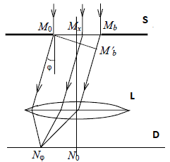

Figure 1 - Fraunhofer diffraction on a single slit

Behind slit there is lens L and in focal plane there is screen D. Presence of lens is meant to create situation like screen would be at infinite distance from slit. If light would propagate in a straight line in accordance with laws of geometric optics, then in a focal plane of lens infinitely narrow light strip can be obtained by passing through the point $N_{0}$ on a screen. But in accordance with the Huygens-Fresnel principle, each point of the wave front reaching plane where gap is located, is a source of spherical waves called secondary waves. We can observe light that leaves slit at an angle $φ$ to a lens and they form wavefront that arrive at screen at location $N_{φ}$.

Let’s calculate field in the plane of the screen using Huygens-Fresnel principle. To do this we divide open part of the slit into smaller slits with width dx parallel to the slit. These elementary sections will be sources of secondary waves with amplitude $dA_{0}$ that arrive at location $N_{φ}$. C is proportionality coefficient. Following formula describes relationship:

$$dA_{0}=CE_{0}dx$$

Phases of oscillations coming from different sections of the slit will differ. To determine phase difference, we draw straight line between $M_{0}M_{b}'$ that is perpendicular to waves direction. Figure 14 shows that path difference between waves coming from point $M_{0}$ or point $M_{x}$ at distance x from point $M_{0}$ is equal to $xsin(φ)$. Therefore, if wave phase coming from $M_{0}$ to point $N_{φ}$ is zero and oscillation $dU_{φ}$ coming from dx near $M_{x}$ into point $N_{φ}$ can be described as follows:

$$dU_{φ}=dA_{0}\cos\left(ωt-kxsin(φ)\right)$$

where $k=\frac{2π}{λ}$ is wave number and $ω$ is oscillation frequency.

Amplitude $A_{φ}$ of the falling wave at point $N_{φ}$ can be calculated as follows:

$${A_{φ}=A}_{0}sinc⁡(\frac{kbsin(φ)}{2})$$

Intensity of light can be calculated as a square of amplitude using following formula:

$${I_{φ}=I}_{0}{sinc}^{2}\left(\frac{kbsin\left(φ\right)}{2}\right)=I_{0}{{\left(\frac{sin\left(u\right)}{u}\right)}^{2}}$$

where $I_{0}$ is intensity in the middle of diffraction pattern.

Intensity I versus sine of the diffraction angle $φ$ is seen on Figure 2. Intensity is maximum at the direction $φ_{0max}=0$ and intensity lowers at larger angle. The angular measure of central diffraction maximum is called diffraction divergence of the beam in the far field.

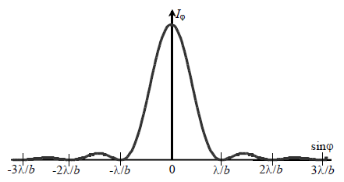

Figure 2 - Intensity distribution for single slit Fraunhofer diffraction

**Diffraction with multiple slits (diffraction grating)**

Let’s consider Fraunhofer diffraction on object which is set of N infinitely long slits having same width b and located at same distance from each other. Such object is called diffraction grating. Let’s denote d as distance between centers of neighboring slits (grating period). Let normally monochromatic light with wavelength $λ$ fall on diffraction grating. To determine intensity of light propagating in a direction making angle $φ$ with a normal, we use Huygens-Fresnel principle.

Amplitudes of light waves at point $N_{φ}$ on on a screen are all equal and described by formula

$${A_{φ}=A}_{0}sinc⁡(\frac{kbsin(φ)}{2})$$

However, there is phase difference between light waves that are coming from other slits described by formula $kxsin(φ)$. We introduce following notation

$$δ=\frac{kbsin(φ)}{2}=\frac{πdsin(φ)}{λ}$$

To get perturbation created by whole lattice it is necessary to sum over all N slits

$${A_{φ}=A}_{0}\frac{\sin{u}}{u}\sum_{n=0}^{N-1}{\exp{-i2δn}}$$

Sum of previous equation is geometric progression and after expansion we can derive intensity of light at point $N_{φ}$

$$I_{φ}=A_{φ}A_{φ}^{*}=I_{0}{\left(\frac{\sin\left(u\right)}{u}\right)}^{2}∙{\left(\frac{\sin\left(Nδ\right)}{\sin{(δ})}\right)}^{2}$$

First term is called diffraction term

$$I_{diffraction}={\left(\frac{\sin\left(u\right)}{u}\right)}^{2}$$

Plotted diffraction term can be seen on Figure 3.

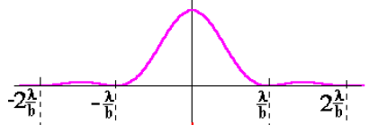

Figure 3 - Diffraction term

Second term is called interference term

$$I_{interference}={\left(\frac{\sin\left(Nδ\right)}{\sin{(δ})}\right)}^{2}$$

Plotted interference term can be seen on Figure 4.

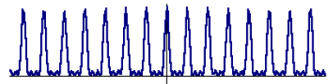

Figure 4 - Interference term

After combining diffraction term and interference term and plotting it, the result is seen on Figure 5.

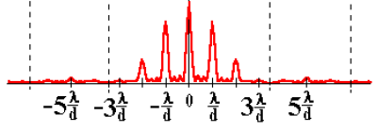

Figure 5 - Diffraction term and interference term combined

By creating diffraction image on a screen and counting number of additional minimums or maximums between primary maximums, it is possible to determine number of slits.

### Laboratory instrumentation

Used equipment: laser, power supply for laser, rotating panel with multiple slits, stepper motor to rotate panel, L298N motor driver to control motor, Arduino development board to give commands over USB, relay to turn power supply on/off and camera to monitor results.

Diffraction lab electronics setup is seen on Figure 6.

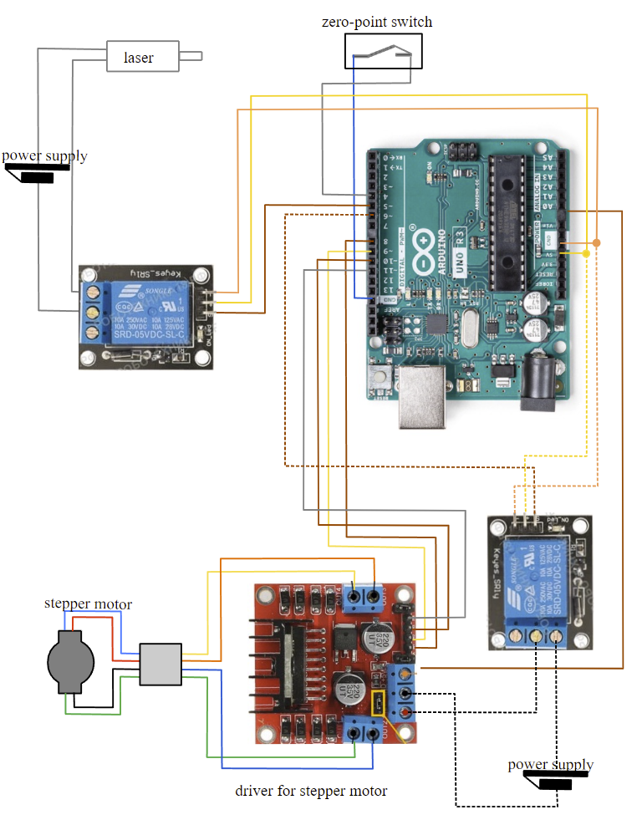

Figure 6 - Diffraction lab electronics setup

### How to use laboratory

Steps to use laboratory:

* Start lab.
* Turn on laser and power for relay.
* Rotate motor clockwise or counterclockwise, so slits would be visible on the screen.
* Save measurement results and leave lab.
* Plot graph of measurement results.
* Depending on the purpose of the experimental work, it is possible to determine the number of slits, the distance between the slits, the distance between the slits and the screen, and the wavelength of laser radiation.